HEALTHCARE SERVICES CHATBOT

OKUMU JOSEPH

The research proposal submitted to the Faculty of Computing and Information technology in partial fulfillment of the award of a degree in Bachelor of Science in Computer Technology of Multimedia University of Kenya

NOVEMBER 2023

DECLARATION AND APPROVAL
STUDENT
I, the undersigned, affirm that this proposal is my original work and that it has not been presented to any other university or institution for academic credit.
Okumu Joseph
CIT-222-054/2020
Signature Date .

UNIVERSITY SUPERVISOR APPROVAL
This research proposal has been submitted for examination with my approval as university supervisor.
Supervisor: Dr. Nicodemus Ishmael
Signature Date .

HEAD OF DEPARTMENT APPROVAL
This research proposal has been submitted for examination with my approval as the head of department.
Head of department: Mr. Henry K. Ndithi
Signature Date .
Department: Information Technology

ACKNOWLEDGEMENT

I express my gratitude to the Almighty God for the wisdom, strength, and protection bestowed upon me throughout this period.
I extend my heartfelt appreciation to the Faculty of Computing and Information Technology through my supervisor Dr. Ishmael, whose guidance and insights have been invaluable in shaping the trajectory of this project proposal. Their support has played a pivotal role in refining the goals and approach of this endeavour. Special thanks also go to my family and friends, whose input has enriched the content and direction of this proposal. Their collaborative efforts are deeply appreciated and have significantly contributed to the development of this project.

DEDICATION

I dedicate this work to my family, especially to my father, for their unwavering support, inspiration, and encouragement throughout this endeavor. Their financial support and moral support have been a driving force behind the development of this proposal. This work is a tribute to their belief in my capabilities and their commitment to my personal and professional growth.

ABSTRACT

The advent of technology has revolutionized various sectors, including healthcare. Healthcare services chatbot research is aimed to develop a chatbot that enhances healthcare services. Chatbots have evolved from being menu/button based to keywords based and now to contextual based. The most advanced of all is contextual based because it uses Machine learning and artificial intelligence techniques to store and process the training models which helps the chatbot to give better and appropriate response when users ask domain specific questions to the bot. The primary objective was to design a chatbot that provides accurate health information, schedules appointments, and offers real-time consultation. The methodology involved the use of artificial intelligence and natural language processing techniques for the chatbot’s functionality. Frontend tools such as HTML, CSS, and JavaScript were used for user interface design, while Python and Django were used for backend development. The chatbot demonstrated a significant improvement in healthcare service delivery by providing timely and accurate health information. It also reduced the workload of healthcare professionals by automating appointment scheduling. In conclusion, the healthcare services chatbot has the potential to transform healthcare service delivery by making it more efficient and accessible.

LIST OF FIGURES
Figure 3. 1 Level 0 Data Flow Diagram (Naymathula , Syed, Srikanth, & Dr. S, 2021) 16
Figure 3. 2 Data flow Diagram (Naymathula , Syed, Srikanth, & Dr. S, 2021) 16
Figure 3. 3 Flowchart (Angappan, Khan, Sharan, & Ahmed, 2021) 17
Figure 3. 4 Context Diagram Source (Research gate) 17
Figure 3. 5 Dataflow Diagram (Author 2023) 18
Figure 3. 6 Data Flow Diagram (Author 2023) 19
Figure 3. 7 Sequence Diagram (Author 2023) 20
Figure 3. 8 Collaboration Diagram (Author 2023) 21
Figure 3. 9 Use Case Diagram of user and admin roles (author 2023) 22
Figure 3. 10 Use case Diagram of the User and AI Chatbot (author 2023) 22
Figure 3. 11 Logical Design of the database source: Bhavani’s Digital Garden (2023) 24
Figure 3. 12 SDLC Agile Software Development Model Source (W3schools.in) 28

Fig 1 Sample Questionnaires source (Author 2023) 37
Fig 2 Gantt Chart Source (Author 2023) 38

LIST OF TABLES
Table 1 Time Schedule Source (Author 2023) 38
Table 2 Budget Source (Author 2023) 39

DEFINITION OF KEY TERMS
Chatbot: chatbot is a computer program that simulates conversation with human end users, often using natural language processing to parse inputs and generate artificial intelligence to automate response
Healthcare: healthcare is the activity or business of providing medical services
Conversational agents (CA): CA is any dialogue system that conducts natural language processing and responds automatically using human language
Artificial intelligence (AI): AI is the simulation of human intelligence in machines that are programmed to think and act like humans
Natural Language Processing (NLP): NLP is the ability of the computer program to understand human like language as it is spoken and written

TABLE OF CONTENTS
DECLARATION AND APPROVAL i
ACKNOWLEDGEMENT ii
DEDICATION iii
ABSTRACT iv
LIST OF FIGURES v
LIST OF TABLES vi
DEFINITION OF KEY TERMS vii
CHAPTER ONE 1
INTRODUCTION 1
1.1. Introduction 1
1.2. Motivation and Background of The Research 1
1.3. Background of The Research 3
1.4. Problem Statements 3
1.5. Aim of Research 4
1.6. Objective of the Research 4
1.6.1. Main Objective of the Research 4
1.6.2. Specific Objectives of the Research 4
1.7. Justification of the Research 5
1.8. Scope of Research 5
1.9. Research Organization 6
1.10. Chapter Summary 6
CHAPTER TWO 7
REVIEW OF RELATED WORK 7
2.1. Introduction 7
2.2. History of the Research Topic 7
2.3. Review of Related Work 8
2.3.1. Conversational Agents in Healthcare: A Systematic Review 8
2.3.2. A Systematic Review of Artificial Intelligence Chatbots for Promoting Physical Activity, Healthy Diet, and Weight Loss 9
2.3.3. Supporting Primary Care Through Symptom Checking Artificial Intelligence: A Study of Patient and Physician Attitudes in Italian General Practice 9
2.4. Review of Related Prototypes, Systems 10
2.4.1. Ada Health 10
2.4.2. Babylon Health 10
2.4.3. Buoy Health 10
2.4.4. Your.MD 10
2.4.5. WebMD Symptom Checker 10
2.5. Emerging Trends and Patterns in the Research Area 11
2.6. Research Gap to be Filled by the Study 11
2.7. Chapter Summary 12
CHAPTER THREE 13
RESEARCH METHODOLOGY 13
3.1. Introduction 13
3.2. Methodology for Literature Review 13
3.3. Methodology for Requirement Specification, Data Collection, and Analysis Techniques 14
3.3.1. Requirements Specifications 14
3.3.2. Data Collection Methods 14
3.3.2.1. Surveys and Questionnaires 14
3.3.2.2. Structured and Semi Structured Interviews 15
3.3.2.4. Participants Observations 15
3.4. Methodology for System Analysis 15
3.4.1. Data Flow Diagram 15
3.4.2. Flowcharts 16
3.4.3. Context Diagram 17
3.5. Methodology for System Design 17
3.5.1. Data Flow Diagram 18
3.5.2. Flowcharts 19
3.5.3. Sequence Diagram 19
3.5.4. Collaboration Diagram 20
3.5.5. Use Case Diagrams 21
3.5.6. Early System Prototype 23
3.5.7. Design of the User Interface 23
3.5.8. Design of the Database 23
3.6. Methodology for System Implementation 24
3.6.1. Backend Technology 25
3.6.2. Frontend Technologies 25
3.6.3. Database Technologies 25
3.7. Methodology for System Testing 25
3.7.1. Testing Plan 26
3.7.2. Testing Techniques 26
3.7.2.1. Unit Testing 26
3.7.2.2. Integration Testing 27
3.7.2.3. System Testing 27
3.7.2.4. User Acceptance Testing 27
3.7.2.5. Performance Testing 27
3.8. Methodology for System Deployment 27
3.8.1. Planning 28
3.8.2. Requirements Analysis 28
3.8.3. Design 29
3.8.4. Development 29
3.8.5. Testing 30
3.8.6. Review and Retrospective 30
3.8.7. Release and Maintenance 30
3.9. Chapter Summary 31
Reference 32
Appendix 37
I. Questionnaire 37
II. TIME SCHEDULE 38
III. Budget Schedule 39

CHAPTER ONE

INTRODUCTION

Introduction
This chapter introduces the healthcare services chatbot project and its foundation. It starts with the motivation, highlighting how AI-driven chatbots can improve patient interactions and address modern healthcare issues. The background section explores the current healthcare situation and the ongoing technological changes. A concise problem statement stresses the need for personalized patient engagement, leading to well-defined research aims and objectives. The chapter explains the research’s significance in breaking communication barriers and reducing healthcare practitioner burnout. It defines the research scope, identifying specific challenges, and prepares the reader for the organized layout of the following chapters.

Motivation and Background of The Research
Chatbots are software developed with machine learning algorithms, including NLP, to stimulate and engage in a conversation with a user to provide real-time assistance to patients. Chatbots have already gained traction in retail, news media, social media, banking, and customer service. Many people engage with chatbots every day on their smartphones without even knowing. From catching up on sports news to navigating bank applications to playing conversation-based games on Facebook Messenger, chatbots are revolutionizing the way we live. Healthcare payers, providers, including medical assistants, are also beginning to leverage these AI-enabled tools to simplify patient care and cut unnecessary costs. Whenever a patient strikes up a conversation with a medical representative who may sound human but underneath is an intelligent conversational machine, we see a healthcare chatbot in the medical field in action (Kalini, 2022). Healthcare service delivery stands at a crucial juncture, marked by increasing demands, the technology achievements, and the need for personalized patient engagement. The integration of artificial intelligence in healthcare has emerged as a transformative solution, with potential to revolutionize patient interactions, optimize care delivery, and address contemporary challenges.
The healthcare sector is undergoing a transformation, driven by technological advancements. The healthcare industry continues to search for and deploy feasible solutions for healthcare practitioner’s burnout to linked to electronic medical and health records (Alim, 2021). This research proposal on healthcare services chatbots is motivated by the potential of these chatbots to revolutionize user interactions with healthcare systems, offering a user-friendly interface that enhances accessibility to healthcare services. Artificial chatbots are used in healthcare to provide patients with a more personalized experience while reducing the workload of healthcare professionals (Team Capacity , 2023)
The research aims at designing an intuitive interface for the chatbot. An easy-to-use interface not only ensures ease of engagement but also plays a crucial role in fostering user trust and engagement with healthcare services. A well-designed interface can significantly enhance the user experience making it easier for users to interact with the chatbot and access healthcare services. This is particularly important in healthcare, where users may be under stress or discomfort. A user-friendly interface can make the process of seeking help less daunting and more efficient (Oleksii, 2021). Furthermore, this study aims at developing a robust backend using AI and NLP techniques. These technologies enable the chatbot to provide accurate health information, schedule appointments, and offer real-time consultations. AI and NLP are at the forefront of technological advancement in healthcare, and their application in chatbot can significantly improve the quality and efficiency of healthcare service delivery (Xu, Sanders, Li , & Chow, 2021).
The motivation for this project is driven by several key factors. The factors include but not limited to, advancement in technology, the rise in chronic diseases, round-the-clock services demand from patients, and reduced operating costs of healthcare providers, are some of the key factors which are expected to drive the healthcare chatbots market forward in the coming years. Chatbots in healthcare are gaining traction, and research suggests that by 2032, the global market for healthcare services chatbot will be worth $944.65 billion. The increase in internet penetration, smart device adoption, and the demand for remote medical assistance drive this market forward (Ottawa, 2023). The healthcare services chatbot identifies their symptoms through a series of queries and guides them to decide whether or not to go see a doctor. This application can be of great benefit to people who are not sure whether their symptoms are transients or require a response to a doctor tests. It also offers advice to users with minor illness, and in that way, encourages people to take appropriate measures to stay healthy, which is a great example of promoting a healthy life (Oh, Zhang, Fang, & Fukuoka, 2021). The inspiration for this research is also rooted in the ambition to overcome the shortcomings of conventional healthcare systems. Essential elements of effective healthcare, such as patient engagement, often encounter obstacles like communication barriers, issues of accessibility, and the pressing need for prompt and precise information. The project aspires to instigate a transformative shift by harnessing the potential of chatbots to deliver immediate, personalized, and readily available healthcare assistance.
In conclusion, this research proposal aims to address these challenges and contribute to the advancement of chatbot technology in healthcare. The proposed research has the potential to significantly improve healthcare service delivery and patient outcomes. Furthermore, it can contribute to the broader field of AI and NLP by developing new techniques and methodologies for chatbot development.

Background of The Research
In the swiftly evolving landscape of healthcare, chatbots are transforming the delivery of healthcare information and services. These tools, powered by artificial intelligence and equipped with natural language processing capabilities, excel at understanding and responding to user queries (Agbo, 2023). Chatbots offer a multitude of benefits in the healthcare sector, providing personalized patient support that includes assessing symptoms, scheduling appointments, managing medication, and even offering emotional and mental health support. Healthcare providers also reap the benefits as chatbots aid in streamlining operations, reducing costs, and improving access to patient data (Kalini, 2022). However, the implementation of chatbots in healthcare presents its own set of challenges, such as ensuring data privacy, maintaining accuracy, and building trust with users. By addressing these issues, chatbots have immense potential to reshape healthcare services, enhance accessibility, and ensure quality in patient interactions (Trotman, 2021).
The creation of a Healthcare Services Chatbot marks a significant stride towards improving the healthcare ecosystem. This project seeks to add to the ongoing efforts to make healthcare more accessible, efficient, and centered around the patient. By tackling the challenges and opportunities in healthcare services, this project aims to enhance patient experiences, empower healthcare consumers, and offer a valuable tool for healthcare providers and organizations.

Problem Statements
Despite the advancement in healthcare, there remains a significant gap in the provisions of timely and personalized healthcare services to patients. The current healthcare system often requires patients to navigate complex processes of simple tasks such as scheduling appointments, seeking health advice, or managing medications. This not only leads inefficiencies but also places a significant burden on healthcare professionals, who must handle routine task in addition to core responsibilities. Furthermore, the lack of round-the-clock support can lead to delayed care, especially for patients in remote or underserved areas. The desired state is a healthcare system that is accessible, efficient, and personalized, where patients can easily access the services they need, and healthcare professionals can focus on providing quality care. The barrier to this is the current state of healthcare delivery, which is often characterized by complex processes, high costs, and limited accessibility. This project aims to address this problem by developing a chatbot that can provide various healthcare-related information and services to users in an interactive and personalized way

Aim of Research
The primary aim of this research is to develop an efficient and user-friendly healthcare services chatbot. This chatbot is intended to enhance the delivery of healthcare services by providing accurate health information, scheduling appointments, and offering real-time consultation. The research aims to address the existing gap in the healthcare sector where patients often struggle to access timely and accurate health information. By leveraging artificial intelligence and natural language processing techniques, this research seeks to devise a solution to this problem and improve the overall efficiency of healthcare service delivery. Ultimately, the research aims to demonstrate that a well-designed healthcare services chatbot can significantly reduce the workload of healthcare professionals and make healthcare services more accessible to patients. This research aim is broad enough to capture the essence of the work, yet concise enough to be easily remembered. It is hoped that by achieving this aim, the research will contribute to the knowledge in the area and provide a foundation for future research in this field.

Objective of the Research

Main Objective of the Research
To design and develop a healthcare services chatbot that can enhance healthcare services by providing accurate information, scheduling appointment, and offering real-time consultation

Specific Objectives of the Research
- To design a user-friendly interface for the chatbot that allows users to easily interact with it and access healthcare service
- To develop a robust backend using artificial intelligence and natural language processing techniques that enable the chatbot to provide accurate health information, schedule appointment, and offer real-time consultation
- To evaluate the effectiveness of the chatbot in improving the efficiency of healthcare service delivery and reducing the workload of healthcare professionals

Justification of the Research
This research is motivated by the existing literature and the gaps identified therein. Chatbots are emerging as a promising platform for accessing and delivering healthcare services. However, their potential in enhancing healthcare service delivery needs to be further explored and understood (Davenport & Kalakota, 2019). While several studies have examined how people feel about using a medical chatbot and how far chatbots are useful to change harmful behaviour, more research is needed to understand the effectiveness of chatbots in providing accurate health information, scheduling appointments, and offering real-time consultation. This research aims to fill this gap by developing a chatbot that can perform these functions effectively. Furthermore, there is growing evidence of the number of publicly available chatbots aiming to take an active role in the provision of prevention, diagnosis, and treatment services. However, their effectiveness in improving the efficiency of healthcare service delivery and reducing the workload of healthcare professionals needs to be evaluated (Kuwaiti, et al., 2023). This research aims to address this need by evaluating the effectiveness of the developed chatbot in these areas.

Scope of Research
The scope of the study for project is defined by the boundaries and parameters within which the research will be conducted. This includes the purpose, population characteristics, geographical location, time period, and theories that the study will focus on. The purpose of the study is to explore the development, implementation, and effectiveness of an intelligent chatbot designed for the healthcare domain. The target population involves users seeking healthcare services through the chatbot, and the study will operate within the context of healthcare service delivery. Geographically, the study is not limited to a specific location, allowing for a broader exploration of the chatbot's applicability. The time period encompasses the duration of the project, covering the phases of design, development, testing, and evaluation. The study focuses on relevant theories related to chatbot functionality, user engagement, and healthcare service enhancement. Overall, the scope is comprehensive, encompassing the entire lifecycle of the healthcare chatbot project within the healthcare domain. Chatbots are emerging as a promising platform for accessing and delivering healthcare services. The evidence is in the growing number of publicly available chatbots aiming at taking an active role in the provision of prevention, diagnosis, and treatment services. Chatbots can improve healthcare quality and efficiency by handling a large volume of patient inquiries, reducing the workload of healthcare professionals, and allowing them to focus on more complex tasks. However, healthcare providers must ensure that chatbots are regularly updated and maintained for accuracy and reliability.

Research Organization
The organizational structure of the research chapters adheres to a systematic framework. Chapter one serves as the introduction and encompasses the problem statement, research justification, and research scope, presenting a continuous prose for the problem statement and anchoring the research justification on existing literature. The subsequent chapters delve into the specifics of the proposed system. Chapter two provides a comprehensive literature review with justified paragraphs and in-text citations, while chapter three outlines the research methodology and design. Figures and tables are labeled and cited appropriately throughout the chapters. The research proposal concludes with a reference section citing all sources consulted.

Chapter Summary
This paper begins with the chapter, Motivation & Background, which sets the context for the project. It starts with the historical development of healthcare services and the growing importance of chatbots, then presents the research background. It clearly defines the problem statement and the existing gaps, leading to the main aim: to explore and enhance the role of chatbots in healthcare delivery. The specific objectives outline the steps to achieve the aim, including chatbot development and effectiveness evaluation. The justification highlights the critical gaps in the current literature, emphasizing the relevance of the study. The scope specifies the operational boundaries, focusing on the target organizations and the system features. Finally, the research organization gives an overview of the structure of the paper. This chapter sets the stage for a thorough investigation of healthcare chatbots, preparing the reader for a research journey that aims to advance the knowledge and practice in this emerging field healthcare chatbots.

CHAPTER TWO

REVIEW OF RELATED WORK

2.1. Introduction
The second chapter of this project reviews the literature on chatbots for healthcare services. It aims to provide a comprehensive overview of the history, features, and effects of chatbots in this domain. This chapter is important because it helps to understand the current state of the art and the potential contributions of the proposed project. The chapter begins with a brief introduction of chatbots in healthcare, focusing on their roles in patient engagement, information delivery, and artificial intelligence integration. Then, it synthesizes the main findings, trends, and gaps from the related work. Finally, it sets the theoretical basis for the next stages of the project, which involve designing and implementing a novel healthcare services chatbot.

2.2. History of the Research Topic
The concept of chatbots emerged in the 1950s from the need for human to interact with computers in a natural human language. The term “Chatterbot” was coined later in 1994. The widespread use of chatbots began just a decade ago with the advent of the internet era and the massive expansions of social networking sites (Frangoudes, et al., 2021). In the healthcare industry, chatbots have rapidly gained popularity. The are AI powered virtual assistant that provide personalized support to patient and healthcare providers. These chatbots are designed to stimulate human-like conversation, enabling patients to interact with theme as they would with a real person (Kalini, 2022). They are trained on healthcare-related data and can respond to many patient inquiries, including appointment scheduling, prescription refills, and symptoms checking. The future of chatbots in healthcare is bright as they keep patient engaged 24/7 and deliver tremendous cost savings. Top health chatbots run on proprietary AI/ML technologies, support non-scripted intent-based dialogs, protect PHI, and make an impression of intelligent being overall. A doctor appointment chatbots is the most straight forward variant of implementing AI-powered conversational technology without significant investment (Kalini, 2022). Chatbots in healthcare have been steadily growing and transforming patient care. They are software developed with machine learning algorithms, including natural language processing (NLP), to stimulate and engage in a conversation with a user to provide real-time assistance to patients. One of the earliest examples of a healthcare chatbot is Florence, named after Florence Nightingale, the founder of modern nursing. Florence acts as a personal health assistant to remind users to track their activity level, body weight, pills, and doctor appointments (Kalini, 2022).
In large companies, like hospitals and aviation organizations, IT architects are designing reference architectures for Intelligent Chatbots that are used to unlock and share knowledge and experience in the organization more efficiently. There are numerous healthcare chatbots such as Your.MD, HealthTap, Cancer Chatbot, VitaminBot, Babylon Health, Safedrugbot, and Ada Health (Parviainen & Rantala, 2022). These chatbots have revolutionized the user experience of tracking vaccines, resolving medical concerns, and booking appointments with doctors (Mamgain, 2022). They can provide a tireless, constant source of interaction for patients with the healthcare system. They are especially useful in gathering routine data, scheduling appointments, administrative work around admissions and discharges, sending reminders, tracking symptoms, creating medical records, facilitating insurance and payment procedures, and telehealth (Dr. Liji Thomas, 2022).

2.3. Review of Related Work
Healthcare chatbots are designed to provide patients with healthcare information, services, and support. They have a range of functions, including responding to patient inquiries, arranging appointments, sending reminders for medication, and even providing mental health support. Research into healthcare chatbots has shown encouraging results, with studies demonstrating their ability to increase patient engagement, reduce healthcare costs, and provide personalized care. Some of the studies include,

2.3.1. Conversational Agents in Healthcare: A Systematic Review
This paper reviews the current state of conversational agents that can interact with users in natural language for health-related purposes. The paper finds that most agents use simple dialogue management techniques, such as predefined scripts or rules, and only a few uses more advanced agent-based approaches. It also finds that the research methods used to evaluate the agents are mostly quasi-experimental, with only two studies using randomized controlled trials. It notes that half of the agents aim to help users with health-related tasks, such as self-care, and one study reports a significant reduction in depression symptoms using a chatbot. However, the paper also highlights the lack of patient safety assessments in most studies. The paper concludes that the research field is still emerging and calls for more rigorous and standardized studies to better understand the effectiveness and safety of conversational agents in health contexts (Laranjo L, 2018)

2.3.2. A Systematic Review of Artificial Intelligence Chatbots for Promoting Physical Activity, Healthy Diet, and Weight Loss
This systematic review assesses the characteristics and effectiveness of AI chatbot interventions in promoting changes in physical activity, healthy eating, weight management behaviors, and related health outcomes. Conducting a comprehensive search across six electronic databases, the study includes only randomized controlled trials or quasi-experimental studies and applies the AI Chatbot Behavior Change Model for analysis. Of the 1692 retrieved citations, 9 studies meet the inclusion criteria, with a focus on physical activity outcomes. While promising, the efficacy of chatbot interventions on diet and weight management remains inconclusive due to limited studies and inconsistent outcome assessments. Notably, chatbot characteristics varied, with a majority using constrained (rule-based) approaches, and gender-specific attributes were often specified. The study underscores the emerging nature of AI chatbots in lifestyle modification programs, emphasizing the need for standardization in design and reporting for future research in this evolving field (JOUR, Jung, Jingwen, Min, & Yoshimi, 2021).

2.3.3. Supporting Primary Care Through Symptom Checking Artificial Intelligence: A Study of Patient and Physician Attitudes in Italian General Practice
In the context of rapid advances in artificial intelligence (AI), the study assesses the attitudes of both patients and physicians in Italian general practice towards AI-driven symptom checkers. Involving ten general practitioners and patients, the feasibility study implemented a chatbot-based symptom checker for anamnestic screening and medical history assessment before medical visits. While the majority of patients did not utilize the symptom checkers, 49% expressed satisfaction, citing ease of use, precise questioning, time-saving potential, and encouragement of self-reflection. Notably, patients were open to at-home use for initial health problem appraisal. The tool had no significant impact on the duration of medical visits, and only a few found it disruptive. Overall, there is a positive reception of the symptom checker, indicating its potential integration into primary care, contingent on careful clinical guidance for maximizing benefits (Mahlknecht , Engl, Piccoliori, & Wiedermann, 2023)

2.4. Review of Related Prototypes, Systems

2.4.1. Ada Health
A German company providing a chatbot that aids patients in diagnosing and managing symptoms. Leveraging natural language processing, the chatbot delivers personalized recommendations for care based on the user's reported symptoms (Parajuli, 2021)

2.4.2. Babylon Health
A UK-based company offering a virtual GP service employing chatbots for patient triage and initial consultations. Utilizing artificial intelligence, the chatbots assess patient symptoms and offer personalized advice to guide users through their healthcare journey. This chatbot assist with the feature of booking a doctor (Brooke, 2017)

2.4.3. Buoy Health
Buoy health offers an AI powered health chatbot that supports self-diagnosis and connects patients to the right treatment endpoints at the right time based on self-reported symptoms. The company said more than one million Americans had used this platform to assess symptoms and seek help during the COVID-19 pandemic (Brooke, 2017)

2.4.4. Your.MD
A UK-based company presenting a symptom checker and health information website. Employing natural language processing, the website interprets user-reported symptoms to provide personalized information regarding potential diagnoses. This chatbot asks about symptoms and puts enough questions approved by health professional to identify a condition probabilistically then sets up appointments, referring you to physician (Brooke, 2017)

2.4.5. WebMD Symptom Checker
A US-based website offering a symptom checker and health information tool. Powered by natural language processing, the tool understands user symptoms and delivers personalized information about potential diagnoses, contributing to informed healthcare decisions. It is a tool that helps you one understands what your medical symptoms could mean, and provides you with trusted information to help make informed decisions about one’s health. (Kovnat, 2016)

2.5. Emerging Trends and Patterns in the Research Area
Conversational artificial intelligence is transforming the field of healthcare, with the aim of enhancing the quality, accessibility, and efficiency of healthcare delivery (Alaa, et al., 2020). The COVID-19 pandemic has boosted the demand for healthcare chatbots, as they play a vital role in screening, triaging, and informing patients and healthcare professionals. Healthcare chatbots have helped to ease the pressure on healthcare systems, offer prompt guidance, and enable remote care delivery amid the pandemic challenges (Parviainen & Rantala, 2022)
Another emerging trend is the popularity of voice-based chatbots, which are favored by users who are elderly, illiterate, or visually impaired. These chatbots provide a more natural and convenient way of communication and can convey empathetic responses. They use advanced technologies such as speech recognition, natural language processing, and speech synthesis (Araujo, et al., 2021)
However, the development of healthcare chatbots also poses ethical dilemmas. As these digital tools become more involved in healthcare interactions, ethical issues have become more relevant. It is essential to ensure the privacy, security, transparency, accountability, and trustworthiness of data and algorithms used by these chatbots (Coghlan, et al., 2023). Ethical guidelines for healthcare chatbots stress the importance of respecting user autonomy, dignity, and preferences, and avoiding causing harm, deception, or manipulation. Compliance with professional codes and standards in the healthcare domain, as well as regulatory oversight, is necessary to address the ethical complexities associated with the use of healthcare chatbots (Parviainen & Rantala, 2022)

2.6. Research Gap to be Filled by the Study
The study is set to address key research gaps that currently exist in the understanding of the relationship between technology and healthcare performance. There is a significant lack of knowledge regarding the intricate link between technological interventions and their impact on healthcare outcomes. This study aims to shed light on this relationship, providing detailed insights into how the integration of chatbot technology can enhance healthcare performance, improve patient outcomes, and streamline healthcare processes (Alaa, et al., 2020)
In addition, the study acknowledges the underuse of existing theories in the field of healthcare technology. Many studies do not effectively apply established theoretical frameworks, which limits the depth of analysis and hinders the development of robust models. The research on healthcare services chatbots aims to address this gap by using and refining relevant theories, thereby providing a solid theoretical foundation for understanding the dynamics of chatbot implementation in healthcare settings (Ward & Gross, 2023)
Another critical aspect that the study seeks to explore is the contextual understanding of technology deployment in healthcare. The current literature reveals a deficiency in acknowledging the diverse contexts within which healthcare technologies operate. By delving into these contextual nuances, the study aims to uncover the intricacies that influence the success or challenges of implementing chatbots in different healthcare environments. This understanding is crucial for tailoring chatbot functionalities to specific healthcare settings, ensuring relevance and effectiveness (Shwetha, Snesha, Varshini, Usha, & Kavya, 2022). Moreover, the current research has not sufficiently explored the effectiveness of chatbots for prevention and intervention in various domains. The existing evidence is scarce, and the study on healthcare services chatbots aims to fill this gap by conducting a thorough evaluation of the impact of chatbots in different healthcare situations. Through empirical research, the study seeks to provide solid evidence regarding the potential of chatbots in avoiding health problems and intervening in a way that improves patient outcomes (Soobiah, et al., 2020)

2.7. Chapter Summary
This chapter navigates through the historical evolution of the research topic, providing a retrospective lens on key developments. The chapter conducts a global-to-local review of related prototypes and systems, exploring their functionalities and limitations. It further outlines emerging trends and patterns in the dynamic landscape of healthcare services chatbot research. A critical aspect of this chapter is the identification of research gaps that the study aims to fill, setting the stage for the subsequent chapters. In essence, it offers a concise yet comprehensive overview, laying the groundwork for the research project by contextualizing the historical journey, surveying existing systems, and pinpointing key gaps in the current understanding of healthcare services chatbots.

CHAPTER THREE

RESEARCH METHODOLOGY

3.1. Introduction
This chapter outlines the data collection techniques or methods that the researcher used to research the proposed area of study. The research methods include the use of questionnaires, use of interviews. Interviews were carried out with the targeted users of the system to design a system that meets their expectations. The above methods laid a large foundation in trying to figure out that gap that has been left behind by the existing web-based online job searching system. Moreover, the chapter provides information about the investigation of the existing system. and it also includes the system requirements specifications, techniques, systems constraints, and the system design tool.

3.2. Methodology for Literature Review
The study follows a systematic process to collect, examine, and consolidate relevant literature. The process begins with the careful formulation of specific research questions that align with the goals of the study and cover key elements of healthcare chatbots. A comprehensive search strategy is then implemented, which includes academic databases, scholarly journals, and credible sources, using keywords related to artificial intelligence, natural language processing, and healthcare chatbots. Explicit inclusion and exclusion criteria are set to sift through the literature based on factors such as the date of publication, whether it's peer-reviewed, and its relevance to the research questions. The process of selecting literature involves a systematic review of titles, abstracts, and full texts to ensure they align with the goals of the study. Information extracted includes main findings, methodologies used, theoretical frameworks, and identified gaps or limitations. The consolidated information is then analyzed to identify common themes, patterns, and trends, which contribute to the creation of a conceptual framework. The quality and reliability of the literature are critically evaluated, and thorough documentation and citation ensure a solid and well-supported literature review. Given the iterative nature of the process, the methodology remains adaptable to include new research, keeping the literature review up-to-date and reflective of the most recent developments in healthcare chatbots.

3.3. Methodology for Requirement Specification, Data Collection, and Analysis Techniques

3.3.1. Requirements Specifications
The Requirements Specifications provides a detailed description of the system's functional and non-functional requirements. It acts as the foundation upon which the "Healthcare Services Chatbot" is built, guiding its development to ensure it effectively meets the needs of its users in the healthcare sector. These specifications serve as a roadmap for the development, implementation, and testing of the chatbot.
Functional requirements outline the specific tasks and operations that the healthcare services chatbot should perform, such as symptom checking, appointment scheduling, and real-time consultation. Non-functional requirements, on the other hand, define the performance, security, and usability standards that the chatbot must meet. Aim is to ensure the chatbot’s effectiveness, reliability, and adherences to ethical and legal considerations in the healthcare domain. These specifications are crucial in ensuring that the chatbot meets its intended purpose, provides a user-friendly experience, and adheres to healthcare regulations and standards. They also facilitate clear communication between all stakeholders involved in the project, ensuring everyone has a shared understanding of the chatbot's capabilities and limitations.

3.3.2. Data Collection Methods
Data collection refers to the process of gathering information as well as solutions to questions. The aim is to get detailed information regarding a specific area of study. This study employs various data collection methods to gather valuable insights and information. These methods include:

3.3.2.1. Surveys and Questionnaires
Survey and questionnaires refer to formal research instruments containing a set of series of questions designed to extract information from a particular group f people, often using closed ended or open-ended questions. They consist of questions presented to individuals or groups, aiming to gather specific information (H., 2017). This tool was utilized to systematically collect feedback and insights from users regarding their experience, preference, and the effectiveness of the chatbot in addressing healthcare needs. They can help understand user preferences, experiences, and expectations from the healthcare services chatbot.

3.3.2.2. Structured and Semi Structured Interviews
Refers to methods of systematically gathering information from a person of group of people through oral communication, with structured interview questions using standardized questions and semi structured interviews allowing for more flexibility (H., 2017). Involves one-on-one conversations between the researchers and participants. Interviews were conducted with healthcare professionals, including doctors, nurses, and administrative staff. Iinterviews provided qualitative data and deeper insights into individual user experiences and needs. These qualitative interactions aimed to explore in-depth perspectives on challenges, expectations, and requirements for integrating the chatbot into existing healthcare processes.

3.3.2.4. Participants Observations
Participants observations is a research method in which the researcher takes part in the daily activities, events and interactions of a group of people as one of the means of learning the explicit and tacit aspects of their live routines and practices. It involved the systematic monitoring and recording of participants’ behavior in real-time (H., 2017). Direct observations were employed on existing system to study how users interacted with the chatbot during actual usage scenarios. This method provided valuable insights into user behavior, preference, and challenges, offering a holistic understanding of the chatbot’s impact on healthcare processes.
These methods ensured a comprehensive understanding of user needs and preferences, guiding the development of a user-centric and effective healthcare services chatbot.

3.4. Methodology for System Analysis

3.4.1. Data Flow Diagram
Data flow diagram refers to visual representation of information flow through a process or system. DFDs help researcher to better understand the process or system operation to discover problems, improve efficiency, and develop better process (Chi, 2023). It shows how data moves throughout the system but does not show program processing steps. However, it provides a logical model that shows what that system does. The diagram below is used to illustrate the process, inputs, and outputs of each process and the flow of data between the processes and the respective data stores
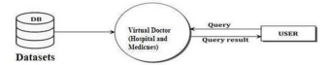
Figure 3. 1 Level 0 Data Flow Diagram (Naymathula , Syed, Srikanth, & Dr. S, 2021)
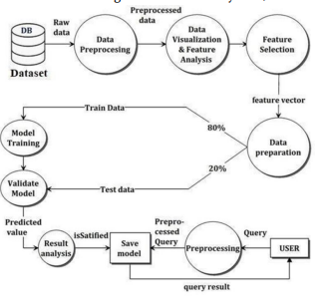
Figure 3. 2 Data flow Diagram (Naymathula , Syed, Srikanth, & Dr. S, 2021)

3.4.2. Flowcharts
Flowcharts is a graphical representation diagram that represents an algorithm, work flow or process. It shows steps in sequential order and is widely used in presenting the flow of algorithms, workflow or processes (Busbee, 2018).

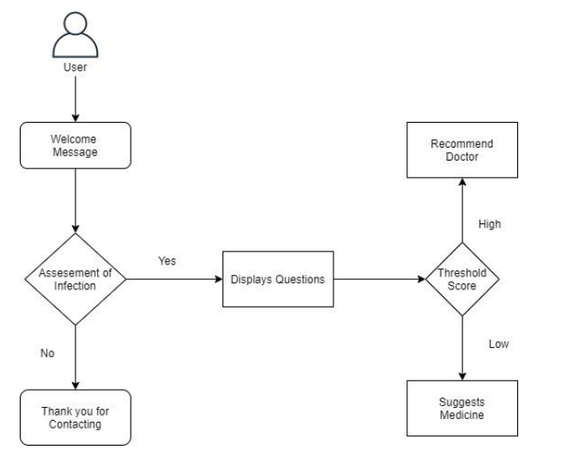
Figure 3. 3 Flowchart (Angappan, Khan, Sharan, & Ahmed, 2021)

3.4.3. Context Diagram
Context diagram show the interaction between a system and other actor s within which the system is designed to interface

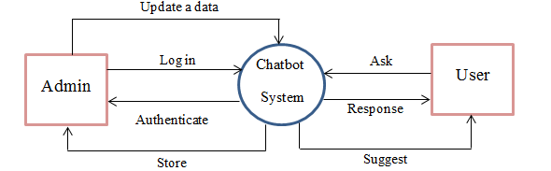
Figure 3. 4 Context Diagram Source (Research gate)

3.5. Methodology for System Design
System design is the phase that gaps between the problem domain and the existing system in a manageable way. It mainly focuses on the solution domain. The system design is categorized as follows

3.5.1. Data Flow Diagram
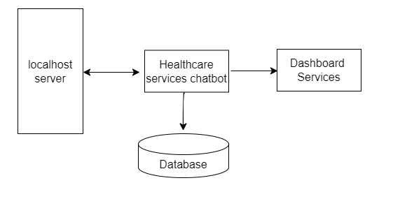
Data flow diagram refers to visual representation of information flow through a process or system. DFDs help researcher to better understand the process or system operation to discover problems, improve efficiency, and develop better process (Chi, 2023).

Figure 3. 5 Dataflow Diagram (Author 2023)

3.5.2. Flowcharts
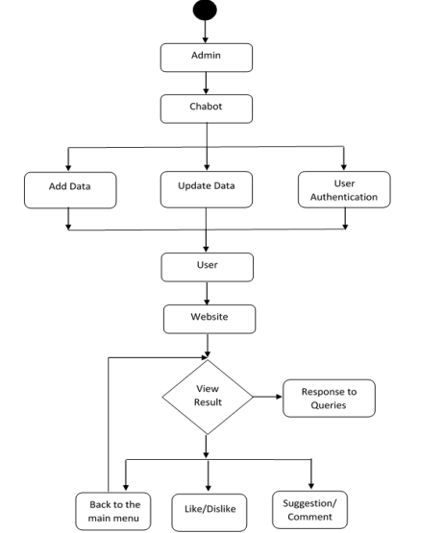
A flowchart is a diagram that uses graphic symbols to depict the nature and flow of the steps in a process. (Cflow, 2023)

Figure 3. 6 Data Flow Diagram (Author 2023)

3.5.3. Sequence Diagram
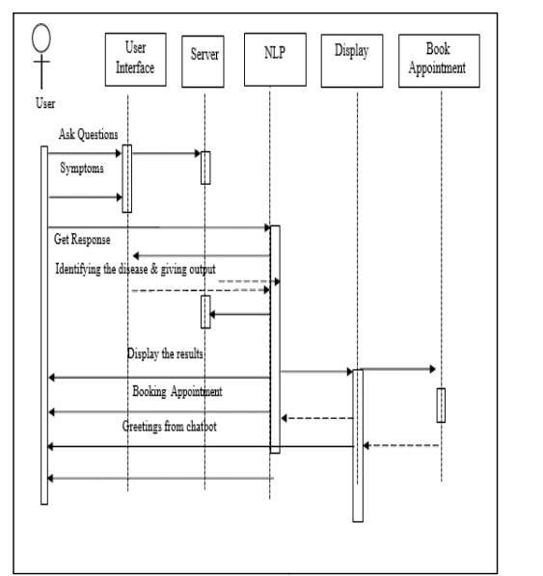
Sequence diagrams are interaction diagram that detail how operations are carried out. They capture the interaction between objects in the context of a collaboration, sequence diagrams are time focus and they show the order of the interaction visually by using the vertical axis of diagram to represent time what messages are sent and when (Visual Paradigm, 2023).

Figure 3. 7 Sequence Diagram (Author 2023)

3.5.4. Collaboration Diagram
Collaboration diagram is an interaction diagram that shows the relationship among objects and how they collaborate to perform a specific behavior or use case (Harry, 2022)
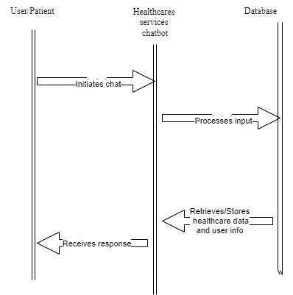
Figure 3. 8 Collaboration Diagram (Author 2023)

3.5.5. Use Case Diagrams
A Use Case Diagram is a type of behavioral UML (Unified Modeling Language) diagram that visually represents the interactions and relationships within a system. It provides a high-level overview of the system’s functionality, showing the different features or capabilities it offers and how users or external systems interact with it
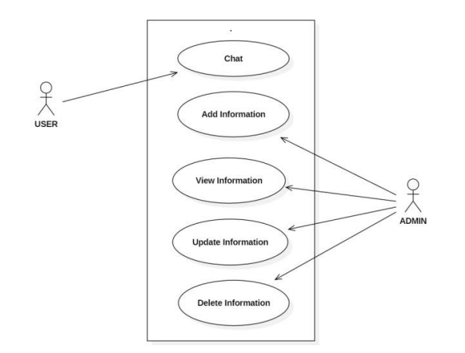
Figure 3. 9 Use Case Diagram of user and admin roles (author 2023)

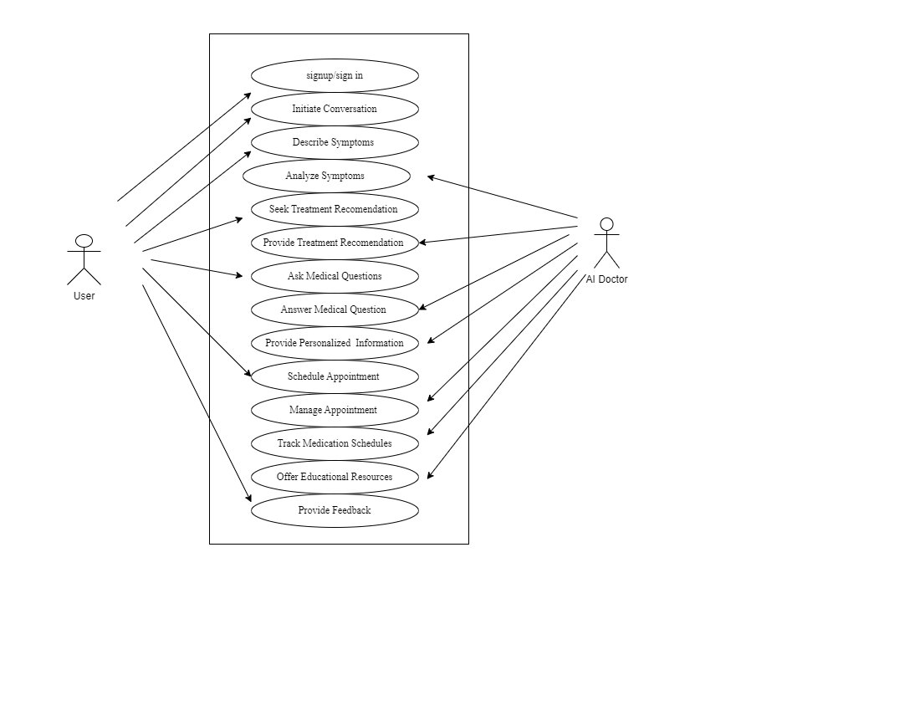
Figure 3. 10 Use case Diagram of the User and AI Chatbot (author 2023)

3.5.6. Early System Prototype
The healthcare service chatbot project focuses on the Input/Output (I/O) design for its initial system prototypes, aiming to create a user-friendly interface for healthcare support. Users can easily input their health-related queries and get clear responses from the system. The chatbot uses natural language processing (NLP) to process various user inputs and understand their healthcare concerns. The system also provides personalized and contextual information or assistance based on user queries. Users can access the chatbot across different platforms with seamless multi-channel integration. The system also collects user feedback to improve its performance and address user suggestions and concerns. The project's goal is to offer an effective, user-friendly, and personalized healthcare support experience through these design objectives.

3.5.7. Design of the User Interface
Embarking on the UI design for my project, my commitment lies in the seamless integration of functionality and visual appeal within the interfaces. As the driving force behind this initiative, the goal is to add a personal touch into the visual appeal and style, ensuring that the interface not only meets high standards of intuition but also serves as a source of delight for users. Whether it involves meticulous design of graphical user interfaces, the central focus remains on elevating the chatbot into an experience that excels in user-friendliness and visual allure. Every element in the design process will undergo thorough consideration, from ensuring smooth navigation to maintaining a cohesive overall design, with the overarching objective of optimizing user interactions and delivering a delightful engagement across diverse platforms and interaction modes.

3.5.8. Design of the Database
Database design refers to set of procedures or collections of tasks involving various steps taken to implement a database (Dotslash , 2023). It is a careful process that organizes data based on a chosen model, acting as a blueprint for how data elements are stored and interconnected. It involves identifying and analyzing data elements in the healthcare domain and the chatbot's functionality, including users, chatbot sessions, health conditions, symptoms, treatments, and feedback. The next step entails selecting a suitable database model, with consideration given to the relational database model for its table-based representation and defined relationships. The database schema design phase creates tables, defines attributes and data types, and establishes key relationships. Additional elements like indexes, views, triggers, and stored procedures are incorporated. Database normalization is crucial for reducing redundancy and enhancing data integrity by adhering to normal forms. The subsequent implementation phase brings the design to life using a chosen database management system, such as Microsoft SQL Server, leveraging SQL for tasks like creating, managing, and manipulating the database. Thorough testing and evaluation ensure alignment with project objectives, encompassing checks for data validation, integrity, and security, with user feedback informing adjustments. This systematic approach aims to establish a robust foundation for the "Healthcare Services Chatbot" project, optimizing functionality while meeting high standards of data integrity and user satisfaction (Hoberman, Burbank, Bradley, & Pomraning, 2009).
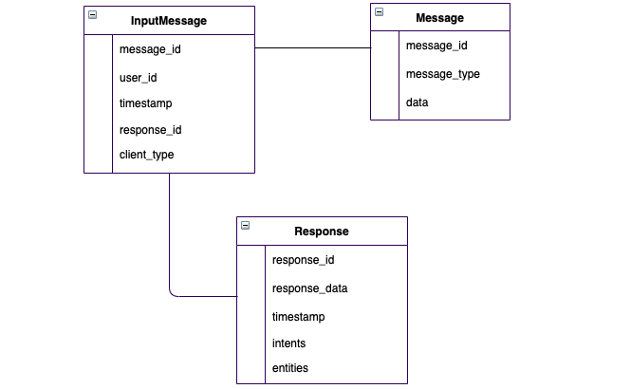
Figure 3. 11 Logical Design of the database source: Bhavani’s Digital Garden (2023)

3.6. Methodology for System Implementation
The methodology for implementing the system involves a strategic approach to utilization of the backend, frontend, and databases technologies. The integration of these components is essential for the seamless development and functionality of the system (Safi, Add-Alrazaq, Khalifa, & Househ, 2020)

3.6.1. Backend Technology
Backend technology refers to the set of technologies and tools used in the server-side development of a system. It handles the behind-the-scenes process, responding to client requests, processing of data, and interacting with databases to deliver a seamless and responsive user experience. Technologies such as python with framework like flask will be considered for the server-side scripting. This backend technology ensures optimal performance, real-time data processing, and responsiveness in delivering healthcare services through the chatbot. (Safi, Add-Alrazaq, Khalifa, & Househ, 2020)

3.6.2. Frontend Technologies
The user interface will be designed with focus on user experience and interactivity. The project incorporates HTML5, CSS and Java script for constructing content, styling and ensuring the dynamic user interface respectively. Thes standard web technologies contributes to the overall visual appeal and responsiveness of the chatbot interface. The frontend technologies selected for this project aim to deliver a user-friendly, responsive, and visually appealing healthcare chatbot interface, enhancing the overall user experience in accessing and interacting with healthcare services. (Safi, Add-Alrazaq, Khalifa, & Househ, 2020)

3.6.3. Database Technologies
On this project, the RDBMS will be employed to store and retrieve data efficiently. Technologies like MySQL or PostgreSQL offer strong data integrity and relational capabilities, making them suitable choices for healthcare related data. The database design will follow best practices, including normalization to minimize redundancy and enhance data integrity (Safi, Add-Alrazaq, Khalifa, & Househ, 2020). The chosen database technologies aim to ensure data integrity, support complex queries, and facilitate seamless integration with the backend infrastructure of the healthcare chatbot project. (Li, Xu, Sanders, & Chow, 2021)

3.7. Methodology for System Testing
System testing verifies that an application performs task as designed. It is the critical system development phase that aims to identify and eliminated defect before the system is released. It involves evaluating the system’s functionality, performance, usability, security, and compatibility with its intended environment. The following methodologies will be used to address aspects of functionality, security, and user experience. Unit testing, integration testing, system testing, security testing, performance testing, regression testing and usability testing (Okonkwo, Amusa , & Twinomurinzi, 2022).

3.7.1. Testing Plan
The testing plan serves as a comprehensive document outlining the testing objectives, scope, approach, and focus to be used ensuring the chatbot aligns with both functional and non-functional requirements while delivering a satisfactory user experience. The plan encompasses several key steps, beginning with the analysis of the chatbot's purpose, functionality, and design, including the identification of user personas, scenarios, and use cases. This phase also defines the test scope, specifying the features to be tested and those excluded from testing. Subsequently, the plan involves designing test strategies and approaches, selecting appropriate methods, techniques, and tools such as unit testing, integration testing. Clear test objectives and pass/fail criteria are established, outlining expected outcomes and quality standards for each test case. Additionally, metrics such as test coverage, defect density, and user satisfaction are defined to gauge the success or failure of the testing process. Planning the test environment and resources follows suit, involving the configuration of hardware, software, network, and data needed for testing. Allocation and management of test resources, including the test team, schedule, budget, and data, are also addressed. Finally, the execution of test cases is carried out according to the plan, with results recorded and reported to stakeholders, accompanied by feedback and recommendations for improvement. This systematic testing approach aims to validate the chatbot's functionality, usability, performance, security, and reliability, ensuring a robust and user-friendly healthcare service chatbot (chatbots life, 2019).

3.7.2. Testing Techniques
This project will employ several testing techniques to ensure comprehensive verification and validation of the system functionalities. The techniques cover different aspects of the chatbot’s performance, usability, and security.

3.7.2.1. Unit Testing
This is a technique involving testing individual components or units of the chatbot, such as intents, entities, actions, and response. Its main purpose is to verify that each unit performs as expected and meets the functional requirements. For example, the, unit testing will be used to check if the chatbot can correctly identify the users’ intents and entity form from a given input, and provide a suitable output (Bai, Smith, & Stolee, 2021).

3.7.2.2. Integration Testing
This technique involves testing the interaction and integration of different units or modules of the chatbot, such as the natural language processing (NLP) engine, the dialogue manager, the database, and the user interface. The purpose is to verify that the chatbot can function as a whole and handle complex scenarios and workflows. For example, integration testing will be employed to check if the chatbot can maintain the context and state of the conversation, and access and update the database as needed (Tsadok, 2020).

3.7.2.3. System Testing
This technique involves testing the chatbot as a complete system, including the hardware, software, network, and data. The purpose is to verify that the chatbot meets the non-functional requirements, such as usability, performance, security, and reliability. For example, system testing can be employed to check if the chatbot can handle multiple users and requests, respond within a reasonable time, protect user data and privacy, and recover from errors and failures (Sharp & Yu, 2019).

3.7.2.4. User Acceptance Testing
This technique involves testing the chatbot with real or potential users, and collecting their feedback and suggestions. The purpose is to verify that the chatbot meets the user expectations and provides a satisfactory user experience. For example, user acceptance testing can check if the chatbot is easy to use, helpful, accurate, and engaging (De Cicco, Iacobucci, Aquino, Romana, & Palumbo, 2022).

3.7.2.5. Performance Testing
This will ensure that the chatbot can handle a large number of users or requests simultaneously without compromising its performance (Vaidya, 2022).

3.8. Methodology for System Deployment
The methodology for system deployment for this project outlines systematic approach to seamlessly introduce the chatbot into the healthcare environment. The project utilizes an Agile methodology for deployment, promoting flexibility and teamwork throughout crucial stages such as planning, analyzing requirements, designing, developing, and testing (Wilson, Bell, Wilson, & Witteman, 2018). Agile approaches are the most popular system development life circle in healthcare (Kokol, 2022).
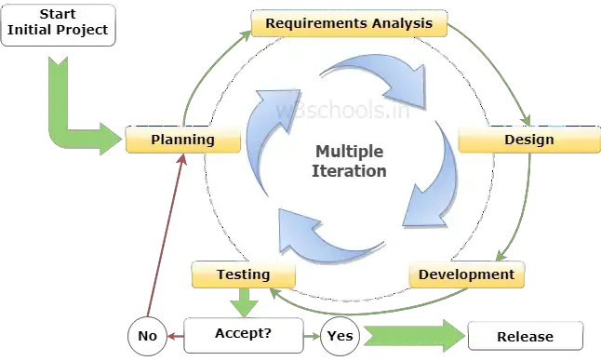
Figure 3. 12 SDLC Agile Software Development Model Source (W3schools.in)

3.8.1. Planning
The primary goal of this phase is to gather the user's fundamental needs. The researcher analyses and gathers the information from the target user(s) and uses it to plan the Business Requirement Specification (BRS) for the product's development. The researcher engaged with the stakeholders to identify the needs of the healthcare service and created a product backlog. The researcher establishes project goals and objectives including all the features that the chatbot should have, such as appointment scheduling, symptom checking, to classify and predict diseases.

3.8.2. Requirements Analysis
Requirement analysis is a critical stage in the software development life circle (SDLC). It involves understanding, capturing, and documenting the customer’s needs and expectations for the software product (Athulya, Jeeshman, Aadithyan, U, & Hairunisha, 2021) This process ensures that the software meets user needs, identifies any limits that need to be considered, and sets a solid base for the next steps in the SDLC (Katherine, 2018). Requirements analysis steps includes identifying user needs, defining chatbot functionalities, identifying the technical requirements, analyzing usability requirements, and understanding the compliance requirements of the healthcare chatbot. Once the researcher has defined and document the user requirements, the subsequent step is then followed.

3.8.3. Design
Design involves creating a detailed design of the system to satisfy the identified requirements from the previous phases. This design is then transformed into a System Design Document that accurately describes the system design and serves as an input to system development in the next phase (Siften, 2021). Design steps includes designing conversation pathway of the chatbot, choosing the right user interface that is intuitive and easy to navigate, fusing the best human and AI to handle routine queries and direct more complex queries to human operators, using natural language processing (NLP) for intent classification and entity extraction, ensuring chatbot comply with regulations such as HIPAA to ensure data security and privacy, and the chatbot should continuously learn from its interactions with users and improve its response overtime. Once the design has been completed the research moves to the next step which is the actual development.

3.8.4. Development
This is where the actual software or system is built. This phase involves translating the design documents into actual code while adhering to all coding standards and guidelines. (Coursera staff, 2023). It involves building the healthcare services chatbot by coding its functionality in the chosen programming language and technologies. This phase includes integrating and testing individual components like the user interface, conversation logic, and database connectivity. Additionally, the technical environment for the chatbot, including servers and databases, is prepared, and AI capabilities such as natural language understanding and machine learning algorithms are implemented. To ensure compliance with healthcare regulations like HIPAA, the chatbot is developed with adherence to these standards. Continuous improvement is an integral part of the development, involving enhancements based on user feedback and ongoing testing. Following the development phase, the chatbot proceeds to the testing phase, where rigorous testing is conducted to verify its alignment with predefined requirements

3.8.5. Testing
During the testing phase of the Software Development Life Cycle (SDLC), the software is scrutinized and validated to confirm it meets the needs of the customer. This phase can involve a variety of tests, such as quality assurance, system integration, and user acceptance tests (Hamilton, 2023).In healthcare services chatbot, a software application that communicates with users in natural language to offer health-related information and services, the testing phase is vitally important. This stage guarantees the chatbot's reliability, accuracy, security, and user-friendliness. The testing activities involve evaluating the chatbot's functionality, performance metrics, usability factors, security measures, and adherence to ethical, legal, and healthcare regulatory standards. Key aspects include assessing the chatbot's ability to understand user queries, provide relevant responses, handle errors, and safeguard user data and privacy. The comprehensive testing process aims to ensure the chatbot's effectiveness and compliance with the highest standards in healthcare services.

3.8.6. Review and Retrospective
The review and retrospective phase in the Software Development Life Cycle (SDLC) is a crucial stage that enables the developers to reflect on the finished project, measure its success, and identify areas for improvement. This phase involves comparing the project's performance with the initial goals, scrutinizing the effectiveness of the processes used, and compiling key lessons learned. In healthcare services chatbot, the review and retrospective phase covers several elements. It includes assessing the chatbot's performance in terms of precision, efficiency, and data protection, analyzing user feedback to determine satisfaction levels, evaluating the efficiency of the development processes, identifying insights and lessons learned specific to the project, and planning for ongoing improvement. This forward-thinking strategy involves making modifications based on user feedback, enhancing development and testing processes, and contemplating the addition of new features or capabilities to boost the chatbot's comprehensive functionality. Developer repeats phases one to six for each sprint until all features in the product backlog have been developed.

3.8.7. Release and Maintenance
The release and maintenance phase marks the concluding stage of the Software Development Life Cycle (SDLC), commencing once the software has been exhaustively tested and greenlit for release. In the release segment of this phase, the software is launched into the production environment, thereby becoming accessible to end-users. This might involve disseminating the healthcare services chatbot across a variety of platforms such as websites, mobile apps, or messaging platforms. The maintenance segment involves providing sustained support for the software post-release. In healthcare services chatbot, maintenance activities encompass corrective measures, adaptations to environmental shifts, enhancements to functionality, and proactive resolution of potential issues. The fundamental objective of the release and maintenance phase is to ensure the enduring effectiveness of the software, persistently meeting the evolving needs of users. In the scenario of a healthcare services chatbot, this translates to ongoing updates and enhancements based on user feedback and advancements in the healthcare field (Talreja, 2023)

3.9. Chapter Summary
This chapter describes the project's methodology in a clear and logical way. It starts with a literature review strategy to find relevant information. Then, it explains the methods for requirement specification, data collection, and analysis, such as interviews and questionnaires. Next, it analyzes the current system using tools like Data Flow Diagrams (DFD), context diagrams, and flow charts. After that, it designs the proposed system, using elements like database design, more DFDs, context diagrams, flow charts, sequence diagrams, collaboration diagrams. It also shows some early prototypes of the system, focusing on Input/Output design. Then, it implements the system, using backend and frontend technologies, and database solutions. It also plans the testing phase, using a testing plan and various testing techniques. Finally, it discusses the system deployment, using a strategic approach to make the chatbot system accessible to end-users.

REFERENCE
Agbo, O. (2023, April 19). MedpageToday's. Retrieved from Revolutionizing health care: How AI-powered tools are reducing workload and improving patient engagement.
Alaa, A. A., Zeineb, S., Mohannad, A., Jim, W., Mowafa, H., & Kerstin, D. (2020). Technical Metrics Used to Evaluate Health Care Chatbots: Scoping Review. Journal of Medical Internet Reseach.
Alim, T. (2021, July 01). HealthTech. Retrieved from How Can Healthcare Leverage Natural Language Processing for Medical Records?: https://healthtechmagazine.net/article/2021/07/how-can-healthcare-leverage-natural-language-processing-medical-records-perfcon
Angappan, A. K., Khan, J. N., Sharan, M., & Ahmed, F. S. (2021). AI Based Healthcare Chatbot System. EasyChair Preprint.
Araujo, T., Law, E. L.-C., Brandtzaeg, P. B., Papadopoulos, S., Reis, L., Baez, M., . . . Luger, E. (2021). Future directions for chatbot research: an interdisciplinary research agenda. Computing.
Athulya, N., Jeeshman, K., Aadithyan, S. J., U, S., & Hairunisha, A. R. (2021). HEALTHCARE CHATBOT. International Journal of Creative Research Thoughts (IJCRT).
Athulya, N., Jeeshna, K., S, A. J., U, S., & Hairunizha, A. R. (2021). Healthcare Chatbot. International Journal of Creative Research Thought (IJCRT), 1.
Bai, G. R., Smith, J., & Stolee, K. T. (2021). How Students Unit Test: Perceptions, Practices, and Pitfalls. ITiCSE 2021: 26th ACM Conference on Innovation and Technology in Computer Science Education.
Brooke, S. (2017, October 24). Medium. Retrieved from How Chatbots Will Shape the Future of Healthcare: https://chatbotsmagazine.com/how-chatbots-will-shape-the-future-of-healthcare-fa8e30cebb1c
Busbee, K. L. (2018). Rebus Community. Retrieved from Programming Fundamentals.
Cflow. (2023, October 10). Retrieved from A Comprehensive Guide to Flowchart Symbols and Notations for Process Workflows: https://www.cflowapps.com/flowchart-symbols/
chatbots life. (2019, November 14). Medium. Retrieved from The Chatbot Testing Checklist: Tools, Techniques, and Metrics to Include in Your Testing Strategy: https://chatbotslife.com/the-chatbot-testing-checklist-tools-techniques-and-metrics-to-include-in-your-testing-strategy-3478a74eb215
Chi, C. (2023, September 06). Hubspot. Retrieved from A beginners Guide to Data Flow Diagram: https://blog.hubspot.com/marketing/data-flow-diagram
Coghlan, S., Leins, K., Sheldrick, S., Cheong, M., Gooding, P., & D'Alfonso, S. (2023, January 01). DIGITAL HEALTH. Retrieved from To chat or bot to chat: Ethical issues with using chatbots in mental health: https://doi.org/10.1177/20552076231183542
Coursera staff. (2023, Noovember 29). Coursera. Retrieved from What Is the Software Development Life Cycle? SDLC Explained: https://www.coursera.org/articles/software-development-life-cycle
Davenport, T., & Kalakota, R. (2019). The potential for artificial intelligence in healthcare. Future Healthcare Journal, 94-98.
De Cicco, R., Iacobucci, S., Aquino, A., Romana, A. F., & Palumbo, R. (2022). Understanding Users’ Acceptance of Chatbots: An Extended TAM Approach. Chatbot Research and Design (pp. 3-22). Cham: Springer International Publishing.
Dotslash , A. (2023). Geeks For Geeks. Retrieved from Database Design in DBMS: https://www.geeksforgeeks.org/database-design-in-dbms/
Dr. Liji Thomas, M. (2022, May 4). Medical and Life Science . Retrieved from The Pros and Cons of Healthcare Chatbot: https://www.news-medical.net/health/The-Pros-and-Cons-of-Healthcare-Chatbots.aspx
Frangoudes, F., Hadjiaros, M., Schiza, E. C., Matsangidou, M., Tsivitanidou, O., & Neokleous, K. (2021, July 03). An Overview of the Use of Chatbots in Medical and Healthcare Education. Learning and Collaboration Technologies: Games and Virtual Environments for Learning (pp. 170-184). Cham: Springer International Publishing. Retrieved from An Overview of the Use of Chatbots in Medical and Healthcare Education: https://doi.org/10.1007/978-3-030-77943-6_11
H., R. B. (2017). Research Methods in Anthropology. Arizona State: Rowman & Littlefield Publishers.
Hamilton, T. (2023, October 7). Guru99. Retrieved from STLC (Software Testing Life Cycle) Phases, Entry, Exit Criteria: https://www.guru99.com/software-testing-life-cycle.html
Harry. (2022, December 30). Boardmix. Retrieved from [Full Guide] Collaboration Diagram in UML: https://boardmix.com/tips/collaboration-diagram/
Hoberman, S., Burbank, D., Bradley, C., & Pomraning, M. (2009). Data Modelling for the Business. In Data Modeling for the Business: A Handbook for Aligning the Business with IT using High-Level Data Models. Technics Publications, LLC.
JOUR, Jung, O. Y., Jingwen, Z., Min, F. l., & Yoshimi, F. (2021). A systematic review of artificial intelligence chatbots for promoting physical activity, healthy diet, and weight loss. International Journal of Behavioral Nutrition and Physical Activity.
Kalini, K. (2022, August 12). TopFlight. Retrieved from Medical Chatbots: The Future of the Healthcare Industry: https://topflightapps.com/ideas/chatbots-in-healthcare/
Katherine, L. (2018, Januray 18). Medium. Retrieved from How to Document Chatbot Requirements: https://chatbotsmagazine.com/how-to-document-chatbot-requirements-7df81275cc66
Kokol, P. (2022). Agile Software Development in Healthcare. Applied Sciences.
Kovnat, L. (2016, September 11). Medium. Retrieved from WebMD and the New App Feature: https://medium.com/@lindzzz56/webmd-group-project-d59ff77bc360
Kropp, M., Meier, A., Biddle, & R. (2016). Agile practices, collaboration and experience. Product-Focused Software Process Improvement, 416-431.
Kuwaiti, A. A., Nazer, K., Al-Reedy, A., Al-Shehri, S., Al-Muhanna, A., Subbarayalu, A. V., . . . Al-Muhanna, F. A. (2023). A Review of the Role of Artificial Intelligence in Healthcare. Journal of Personalized Medicine .
Laranjo L, D. A. (2018). Conversational agents in healthcare: a systematic review. Journal of the American Medical Informatics Association.
Li, k., Xu, L., Sanders, L., & Chow, J. C. (2021). Chatbot for Health Care and Oncology Applications Using Artificial Intelligence and Machine Learning: Systematic Review. JMIR cancer.
Mahlknecht , A., Engl, A., Piccoliori, G., & Wiedermann, C. J. (2023). Supporting primary care through symptom checking artificial intelligence: a study of patient and physician attitudes in Italian general practice. BMC Primary Care.
Mamgain, D. (2022, October 22). Healthworld. Retrieved from Chatbots in Healthcare: An essential tool for an essential service: https://health.economictimes.indiatimes.com/news/health-it/chatbots-in-healthcare-an-essential-tool-for-an-essential-service/95026441
Naymathula , K., Syed, B. H., Srikanth, K. S., & Dr. S, S. (2021). Medical Chatbot. International Journal of Scientific Research in Science, Engineering and Technology | www.ijsrset.com.
Oh, J. Y., Zhang, J., Fang, M.-L., & Fukuoka, Y. (2021). A systematic review of artificial intelligence chatbots for promoting physical activity, healthy diet, and weight loss. International Journal of Behavioral Nutrition and Physical Activity.
Okonkwo, C. W., Amusa , L. B., & Twinomurinzi, H. (2022). COVID-Bot, an Intelligent System for COVID-19 Vaccination Screening: Design and Development. JMIR Form Res.
Oleksii, G. (2021, November 21). Acropolium. Retrieved from CHATBOTS IN HEALTHCARE: DEVELOPMENT AND USE CASES: https://acropolium.com/blog/chatbots-in-healthcare/
Ottawa. (2023, January 04). Precedence Research. Retrieved from Healthcare Chatbots Market Size to Surpass USD 944.65 BN by 2032: https://www.globenewswire.com/en/news-release/2023/01/04/2582717/0/en/Healthcare-Chatbots-Market-Size-to-Surpass-USD-944-65-BN-by-2032.html
Parajuli, B. (2021, April 11). Benzinga. Retrieved from BEST CHATBOT SERVICES FOR HEALTHCARE: https://www.benzinga.com/business/best-chatbot-services-for-healthcare
Parviainen, J., & Rantala, J. (2022, September 04). Chatbot breakthrough in the 2020s? An ethical reflection on the trend of automated consultations in health care. Medicine, Health Care and Philosophy. Retrieved from Chatbot Breakthrough in the 2020s? An ethical reflection on the trend of automated consultations in health care: https://link.springer.com/article/10.1007/s11019-021-10049-w
Safi, Z., Add-Alrazaq, A., Khalifa, M., & Househ, M. (2020). Technical Aspects of Developing Chatbots for Medical Applications: Scoping Review. J Med Internet Research.
Sawad, A. B., & al, e. (2022). A Systematic Review on Healthcare Artificial Intelligent Conversational Agents for Chronic Conditions. Sensors (Basel).
Sharp, I., & Yu, K. (2019). System Testing. Wireless Positioning: Principles and Practice (pp. 329-388). Singapore: Springer Singapore.
Shwetha, M. P., Snesha, S., Varshini, S., Usha, J. M., & Kavya, M. (2022). Design & Implementation of Healthcare Chatbot. International Journal of Engineering Research & Technology (IJERT), 57-58.
Siften, H. (2021, Feruary 20). OpenXcell. Retrieved from SDLC Design Phase – Everything You Need to Know: https://www.openxcell.com/blog/design-phase-in-sdlc/
Soobiah, C., Cooper, M., Kishimoto, V., Bhatia, S. R., Scott, T., Maloney, S., . . . Desveaux, L. (2020). Identifying optimal frameworks to implement or evaluate digital health interventions: a scoping review protocol. BMJ Open.
Talreja, A. (2023, June 19). Teaching Agile. Retrieved from SDLC Maintenance Phase: Ensuring Success of Your Software: https://teachingagile.com/sdlc/maintenance
Team Capacity . (2023, May 19). Capacity . Retrieved from Chatbots in Healthcare: Improving Patient Engagement and Experience: https://capacity.com/learn/ai-chatbots/chatbot-in-healthcare/
The ChatC Group. (2020, December 2). Medium. Retrieved from 3 Amazing Examples Of Automation In Healthcare — ChatC: https://medium.com/a-chatbots-life/3-amazing-examples-of-automation-in-healthcare-chatc-41164c9efcc2
Thomas, E. E., Haydon, H. M., Smith, A. C., & al., e. (2020). Building on the momentum: Sustaining telehealth beyond COVID-19. Sage Journal.
Top. (n.d.). Medical Chatbots.
Trotman, J. (2021, August 20). Nimble Appgenie. Retrieved from Top Benefits, Risks and Challenges of Chatbots in Healthcare: https://www.nimbleappgenie.com/blogs/challenges-of-chatbots-in-healthcare/
Tsadok, A. (2020). Integration Tests. Pro iOS Testing: XCTest Framework for UI and Unit Testing (pp. 113-139). Berkeley, CA: Apress.
Vaidya, N. (2022, January 31). Browser Stack. Retrieved from ChatBot Testing : A Beginner’s Guide: https://www.browserstack.com/guide/what-is-chatbot-testing
Visual Paradigm. (2023). Retrieved from What is Sequence Diagram?: https://www.visual-paradigm.com/guide/uml-unified-modeling-language/what-is-sequence-diagram/
Ward, E., & Gross, C. (2023). Evolving Methods to Assess Chatbot Performance in Health Sciences Research. JAMA Intern Med. 2023;183(9):1030-1031.
Wilson, K., Bell, C., Wilson, L., & Witteman, H. (2018). Agile research to complement agile development: a proposal for an mHealth research lifecycle. npj Digital Medicine.
Xu, L., Sanders, L., Li , K., & Chow, J. (2021). Chatbot for Health Care and Oncology Applications Using Artificial Intelligence and Machine Learning: Systematic Review. . JMIR Cancer.

APPENDIX

Questionnaire
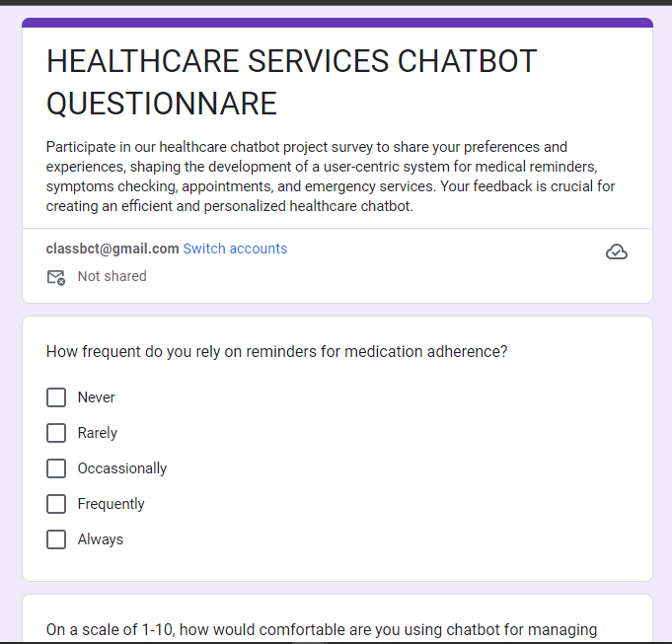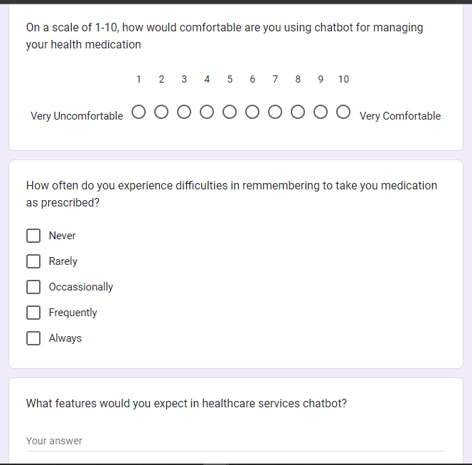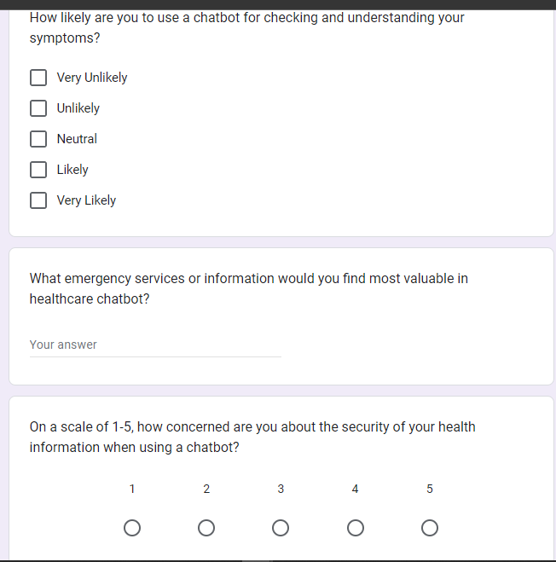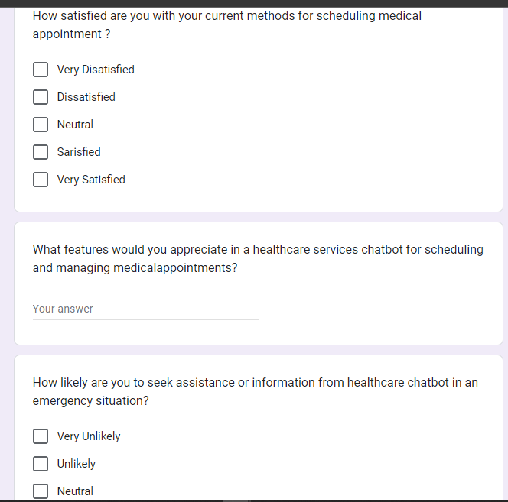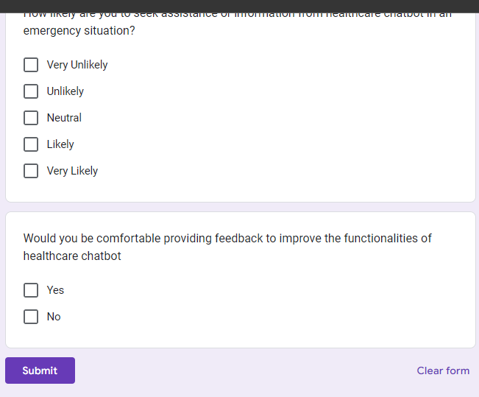
Fig 1 Sample Questionnaires source (Author 2023)

TIME SCHEDULE
A time schedule provides a detailed outline of tasks, each with their projected timeframes in days, weeks, and months. This schedule acts as a thorough timeline, offering a clear guide for the project's initiation, planning, design, development, testing, deployment, and continuous maintenance stages.

TASKS | DURATION  (WEEKS) | EXPECTED START DATE | EXPECTED END  DATE
Planning | 3
Requirement Analysis | 8
Design | 9
Development | 15
Testing | 15
Review and Retrospective | 3
Deployment and maintenance | 6
Documentation | 15

Start
END

Table 1 Time Schedule Source (Author 2023)

Gnatt Chart representation
Fig 2 Gantt Chart Source (Author 2023)

Budget Schedule
The proposed budget for this project is outlined below, detailing the necessary resources and their anticipated costs for the project’s development.
 | ITEM | QUANTITY | COST PER ITEM (KSH)
1 | Computer | 1 | 30000
2 | Flash Drive | 1 | 1500
3 | Bundles |  | 2000
4 | Transport |  | 2500
5 | Other |  | 2000
 | Total |  | 38000

Table 2 Budget Source (Author 2023)

